Filter Chain
Technical Overview

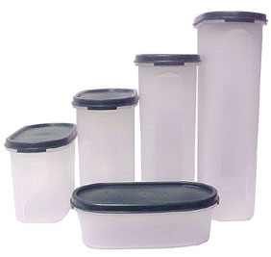

Revision 0.2
7/18/2003

Copyright 2001-2003 Avalanche Software
Proprietary and Confidential Information
TABLE OF CONTENTS
Introduction 3
What is Tupperware? 3
What is the Tupperware Graphics Definition? 3
Filter Chain Components 4

Introduction
This document is an overview of the applications and components that convert data from source artwork into platform specific data formats. Emphasis is placed on allowing filters to be generated that can perform a specific task for a particular game or platform. The filter chain relies on the Tupperware format as well as the Tupperware Graphics format when passing data from filter to filter. Each filter used within the chain is able to add data to the data hierarchy as well as export any information desired by that filter.

What is Tupperware?
Tupperware uses basic building blocks (Atoms); aggregates, scalars, and lists to store its data. This data is arranged in a hierarchy to make it easier to access. Each building atom has a key and a name. The key is a string used for finding and is not optional. The name is optional and is used to distinguish between atoms that have the same key or to hold additional information.
An aggregate atom holds no data but has child atoms. A scalar holds a single piece of data; integer, float, string, or binary. A list holds an array of data; integers, floats, or strings.
The Tupperware library allows for interacting with the atoms as well as supporting an ASCII as well as a binary file format.
Using Tupperware allows for representing the graphic data in a general way that allows for expandability as well as for data outside of this definition to be stored in a transparent way.

What is the Tupperware Graphics Definition?
The Tupperware Graphics Definition is a specific layout of 3d graphics data using the Tupperware building blocks. This definition mirrors much of how 3d Studio Max v4 has its internal data structures built and will allow future data from Max to be easily exported from Max without having to drastically change the format. This definition has evolved to due to the fact that Maya is now used instead of Max. This definition will adapt to not only the source artwork from Maya but any other common data structures that are used often may be added, i.e. Triangle Strip data, breaking objects into multiple pieces, etc.

Filter Chain Components
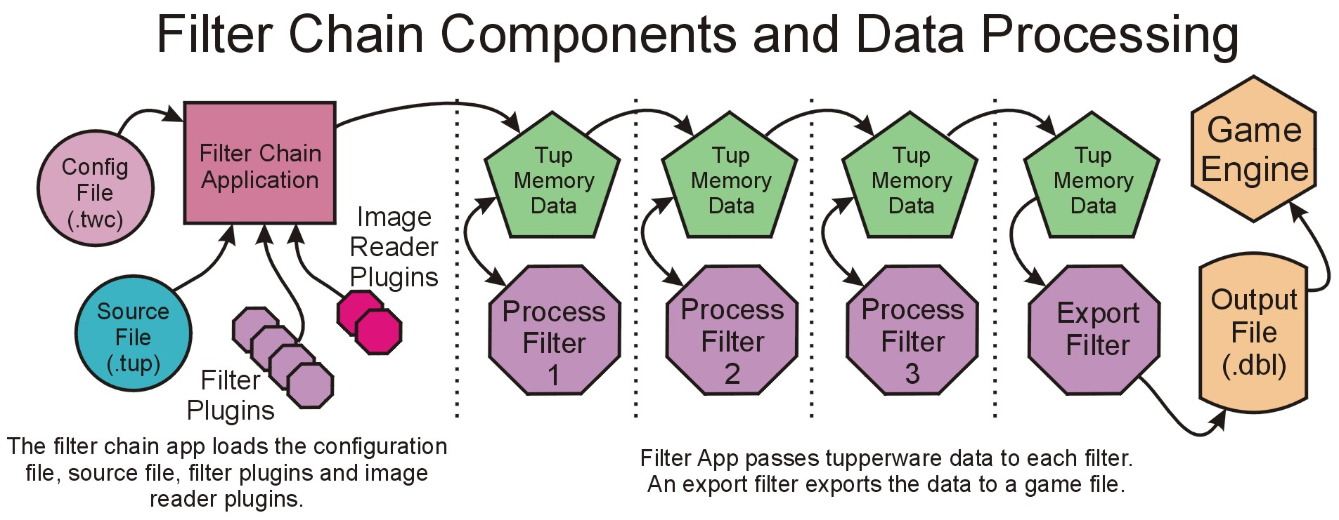
The following illustration shows the various components of the filter chain:

Filter Chain Application
This application connects all the pieces together. It is in charge of reading the source and configuration files as well as the plugins. It passes the Tupperware data from filter to filter. The Filter Chain Application is comprised of a command line and a GUI version. The command line version is able to override any options from the configuration file. The GUI version is used to easily provide input files and execute the Filter Chain on a single source file.

Filter Chain Configuration File
This file is a text file generated by the user. It outlines which filters are to be run, in which order as well as options for these filters. Each game and platform would have its own configuration file. Which configuration file the application will load is passed as a command line option.

Tupperware File
This is the data to run through the filter chain. It may passed as a file (in the case of the Filter Chain Application) or through memory in the case of a plugin in Max. This represents the data from Max before it has been run through any filters.

Tupperware Memory Data
This is the data that runs through the filter chain. It is passed by pointer from one filter to another. If a filter needs to add additional data it may attach it anywhere within the Tupperware tree.

Filters Plugins
A filter plugin can manipulate the Tupperware Memory data as well as export the data to a file. These plugins are DLLs and are loaded by the Filter Chain Application at run time. A Manipulation filter usually will process the data and add new data within the database. An Export filter usually sits as the last filter in the chain and will export the data to the correct format. There is no difference between the two filters except in what they choose to do. Every filter may manipulate the Tupperware data. They may also export data. It is up to the filter programmer to determine what the given filter will do.

Image Reader Plugins
An image reader plugin is used for accessing the various texture file formats. The Filter Chain Application will automatically search for these plugins and call their GetImageData function when a file needs to be loaded. The plugin will then attempt to read the file and convert it into a Tupperware tree. This tree is passed to the application and is available to any of the filter plugins.

